Vincent Deprez Tourbillon Classique Souscription Edition
The Tourbillon Classique Souscription Edition by Vincent Deprez is a classically proportioned, beautifully finished timepiece by Vincent Deprez. With a case diameter of 39 mm, the Tourbillon Classique features an open dial revealing a 60-second tourbillon.

Handmade using traditional tools, the Souscription Edition is a limited edition of 10 pieces in stainless steel with a dark blue or cream-colored oven-fired subdial displaying hours and minutes. There will only be 20 movements made in total.

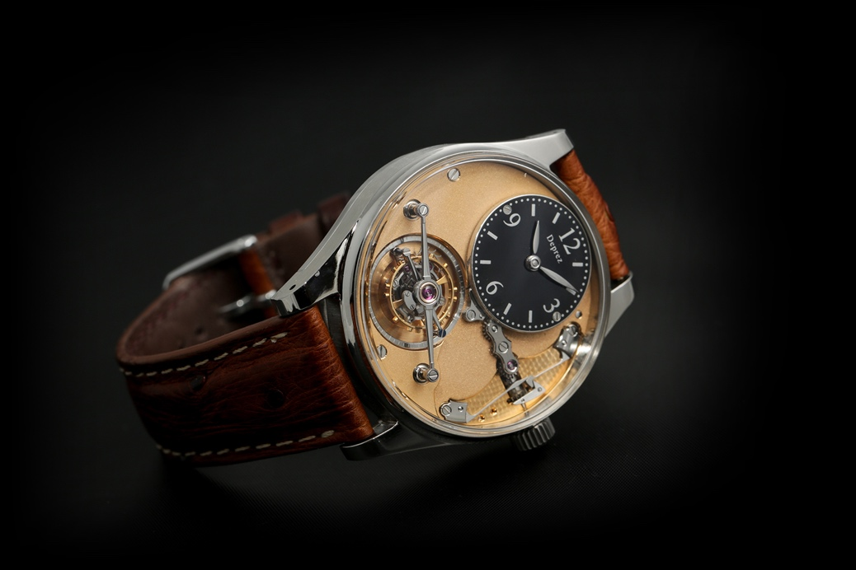

Vincent Deprez
Vincent Deprez is a French watchmaker living near Geneva. From childhood he always liked working with his hands and he first thought about being a watchmaker when he was just 12 years old. Two years later, his watchmaking dream turned into a passion after doing a school work experience week at Vacheron Constantin. This led him to a watchmaking apprenticeship with Vacheron Constantin at the horologically precocious age of 15 years.
After ten years at Vacheron Constantin working in restoration, regulation, assembly, and ultra-thin watches, Vincent moved to Patek Philippe where he worked in the restoration department. A yearning to make his own watch grew ever stronger, and in 2017 he left Patek Philippe to set up his own atelier and begin working on making his own tourbillon. With his passion for traditional watchmaking, Vincent decided at the outset that he would make handmade watches using traditional tools.

Handmade
Vincent Deprez makes the Tourbillon Classique by hand using traditional tools. Vincent makes the movement components (including tourbillon cage), case, and even fires his own enamel dials. The only components not made by Vincent are the strap, buckle, jewels, mainspring, balance spring, balance wheel, hands, sapphire crystals, mainspring barrel, and 90° gearing in the winding mechanism.

Tourbillon Classique Souscription Edition
The dial side is dominated by a 60-second tourbillon suspended under a large, beautifully polished bridge. Vincent chose to display hours and minutes on a small dial to show off as much of the winding and setting mechanism as possible. The visible main plate features a traditional frosted finish, which was common on historic high-end watches.
The 60-second tourbillon movement is an original Vincent Deprez design and construction. The back features a traditional frosted finish and hand-polished anlage with sharp internal angles. Jewels and screws sit in hand-polished countersinks; the screw heads are also hand-polished. A neatly concealed spring barrel click runs around the curve, following the outline of the numbered edition disk.
The hand-polished, 39 mm diameter, 316L stainless steel case is handmade from a blank by Vincent Deprez. The backplate framing the sapphire crystal display back is set into the case to maximize the slim profile of the watch.

Image download at https://vincentdeprez.watch/

Specifications : Vincent Deprez Tourbillon Classique Souscription Edition
Indications: hours, minutes, seconds (indicated around the tourbillon cage)
Case: 316L stainless steel
Dimensions: 39 mm diameter x 11. 3 mm high
Movement: handmade, one-minute tourbillon, high-level finishing, tourbillon cage 12.6 mm, tourbillon bridge 22.8 mm, balance spring with Breguet overcoil, limited to 20 pieces
Jewels: 15
Frequency: 2.5 Hz/18,000 vph
Dial: dark blue or cream-colored oven-fired enamel, 18 mm diameter
Power reserve: 52 hours
Water resistance: 30 meters
Strap: ostrich leather
Dial: oven-fired, entirely handmade by Vincent Deprez using traditional tools and machines
Presentation case: walnut
Limitation: 10 pieces in stainless steel
Price: 89,500 Swiss francs (excluding shipping and any applicable taxes)

Contact
For more information or how to order a Vincent Deprez timepiece, please email contact@vincentdeprez.watch

www.vincentdeprez.watch
Vincent Deprez
21b Chemin des Bois
1255 Veyrier
Switzerland

